Task Management

Task management is the systematic process of planning, organizing, prioritizing, and overseeing the completion of activities within a specified timeframe. It involves the coordination of resources, time, and efforts to achieve specific goals and objectives. Effective task management is crucial for individuals and teams to stay focused, meet deadlines, and optimize productivity.

1. CONFIGURATION

* Download files from GITHUB
  + Link: <https://github.com/Agileaxpert/Axpert>
* Import the structures in RUN instance using Axpert manager
* Run the SQL scripts
* Create a html page in developer studio (say Task Management) and add the JS and CSS files to the HTML page
* Add custom hyperlink to open this page from iview.
  1. Screens

The purpose of this page is to show the user how to set up all the sections under the task management module. The following report and screens have to be imported.

**SCREENS:**

1. Project Master
2. Category Master
3. Subcategory Master
4. Task Form
5. Status Update

**REPORT:**

1. Task Management
   * 1. **PROJECT MASTER :**

Offers a detailed breakdown of all tasks associated with the project. It stores general information about each project, including Start date, end date, project users, project name and description of each project.

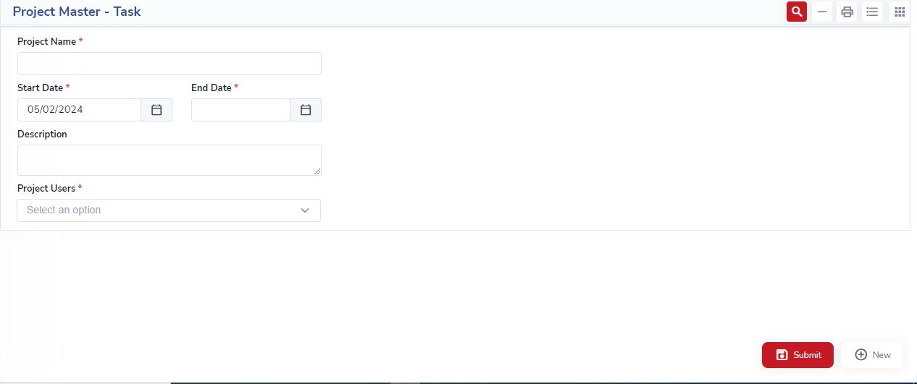

* + 1. **CATEGORY MASTER :**

A Category Master is a feature that allows users to categorize tasks based on predefined categories. This helps in organizing and classifying tasks, making it easier for users to filter and prioritize their work. It includes the fields Category Name, Actor and Description.

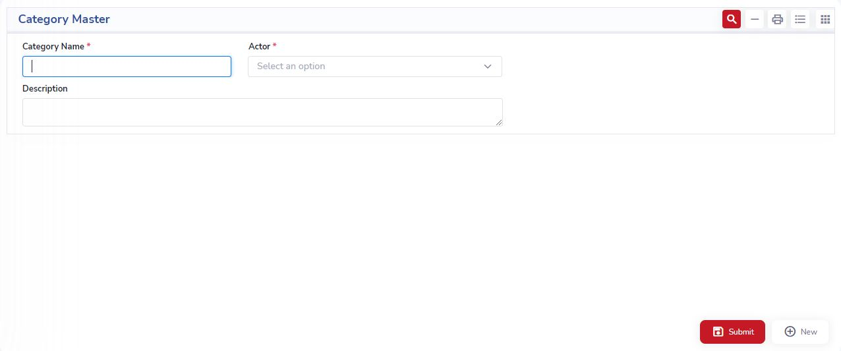

**1.1.3 SUBCATEGORY MASTER:**

A Subcategory Master can be added to further categorize tasks within broader categories. This allows for a more granular organization of tasks. It includes the fields Category Name, Sub Category Name, Description and User.

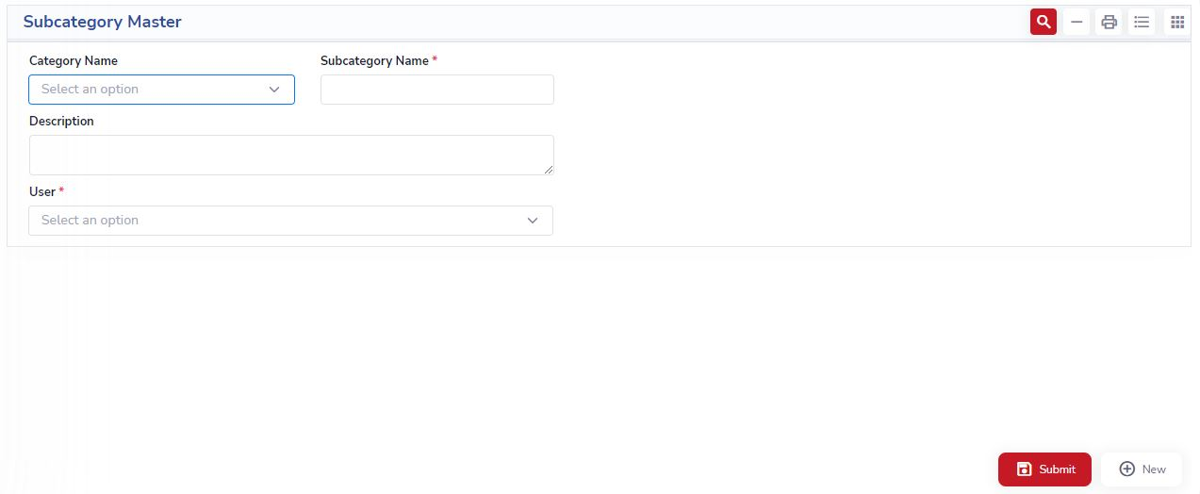

**1.1.4 TASK FORM:**

The task form in a simple task management system serves as the user interface for entering and updating information related to individual tasks. It is a crucial component that facilitates the seamless interaction between users and the task management system. It includes the fields:

1. **Task Number:** A unique identifier assigned to each task for easy tracking and reference.
2. **Task Date:** The date when the task was created or initiated, providing a chronological record.
3. **Task Initiator:** The person or entity responsible for initiating the task, helping to identify the point of origin.
4. **Due Date:** The deadline by which the task needs to be completed, aiding in time management and prioritization. It will allow user to enter current date and future date.
5. **Completed:** A checkbox or indicator to mark whether the task has been successfully completed or not.
6. **Category:** The broad classification or type of task, helping to organize and group similar tasks together. It represents a dropdown field populated with values based on the selected category in the preceding field from category master screen.
7. **Project:** The specific project or initiative to which the task is related, providing context for its purpose. It represents a dropdown field populated with values based on the selected project in the preceding field from project master screen**.**
8. **Subcategory:** Further refinement of the task's category, offering additional classification details.
9. It represents a dropdown field populated with values based on the selected subcategory in the preceding field from Subcategory master screen
10. **Department:** The department or team responsible for handling the task, facilitating efficient task assignment.
11. **Description:** A detailed description of the task, outlining its objectives, requirements, and any specific instructions.
12. **Files:** An option to attach relevant files or documents to the task for additional reference or information.
13. **Pending With:** Indicates the person or department currently responsible for the ongoing status of the task.
14. **Priority:** A level of importance or urgency assigned to the task, helping in prioritizing workload.

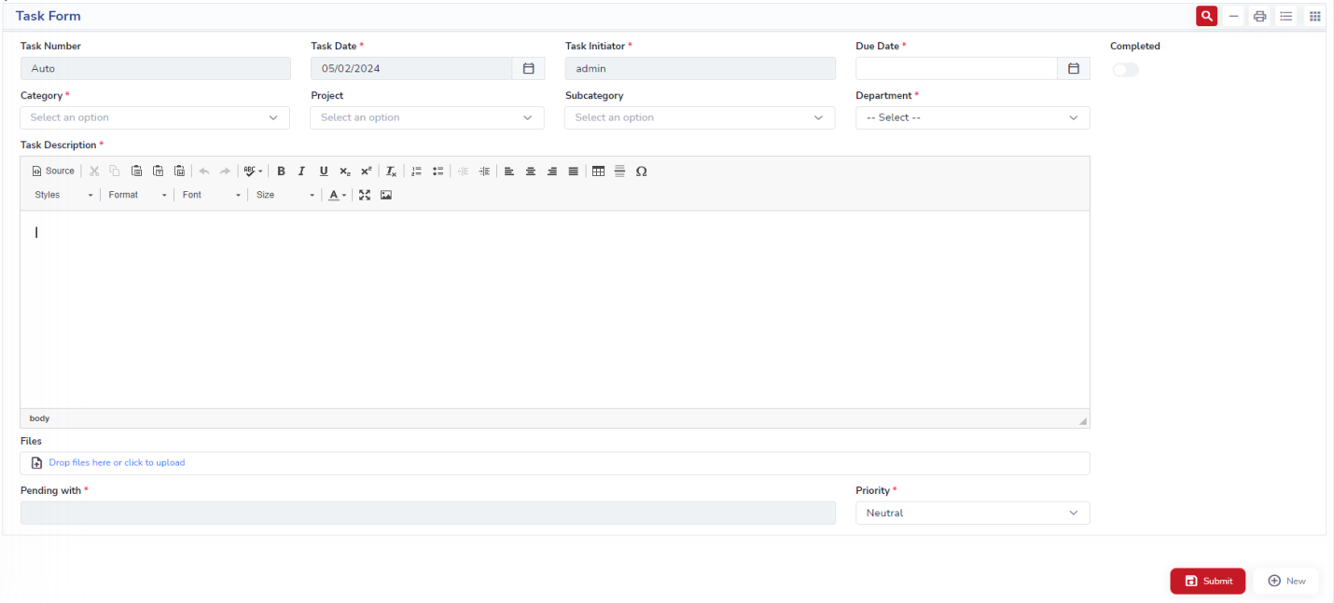

**1.1.5 STATUS UPDATE**

The "Status Update" captures key information related to the progress, actions, and communication associated with each task. It allows you to maintain a log of updates and actions related to each task, helping to track the task's progress and communication history.

1. Task number: Reference to the task to which the status update belongs (linked to the task number in the Tasks form).
2. Assigned by: Indicates the person or entity responsible for the status update.
3. Action: Describes the action taken .(Completed, Completed and closed, Forward, reassigning, Reply)
4. Reply/forward to: Specifies if there's a reply or if the update is forwarded to someone else
5. Action description: Provides additional details or comments about the action taken.
6. Attachments: May contain file names or links to attachments associated with the status update.

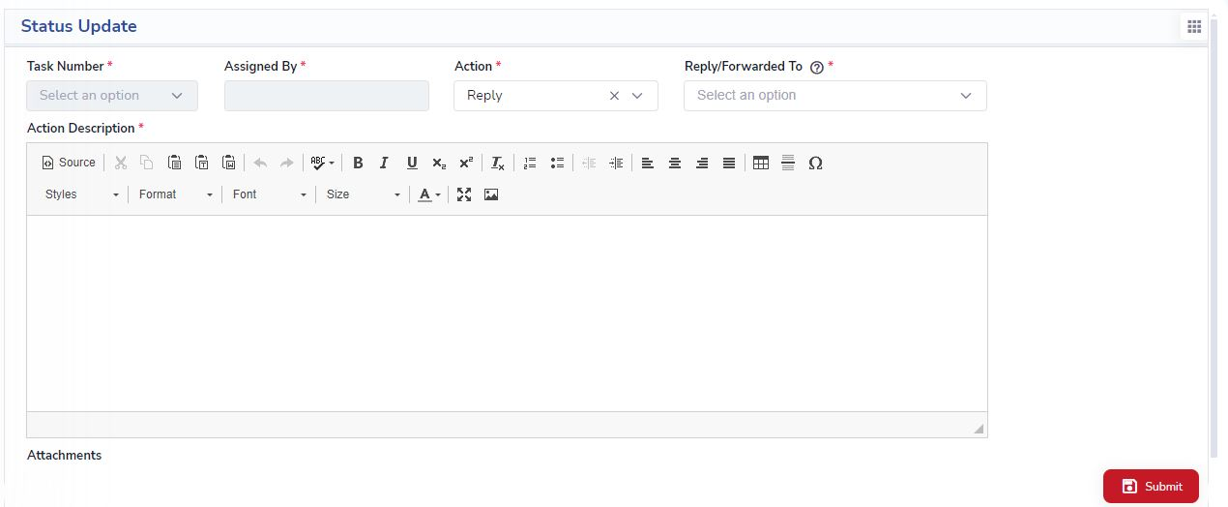

**REPORT:**

**Task Management:**

Fields in this report includes task number, task details, task date, due date, status (completed or pending) and Action.

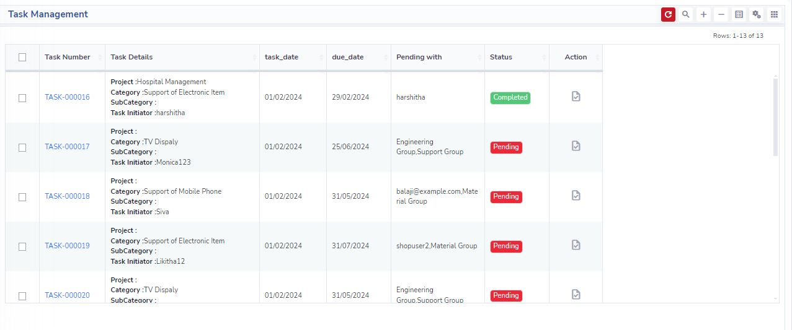

The user can click on the action icon for a particular task number which takes the user to the Task Page .

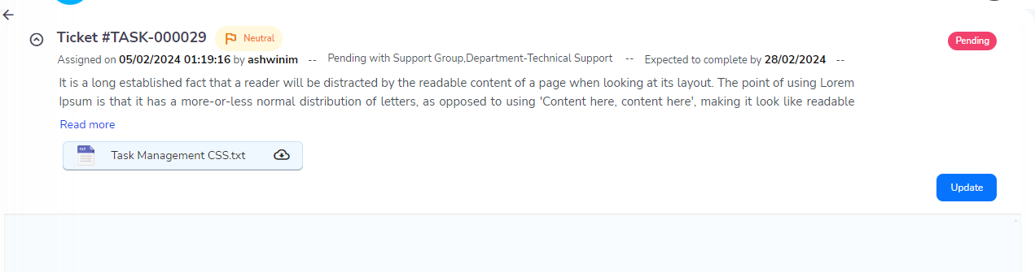

From update button particular user or group users can access to Status Update Screen.

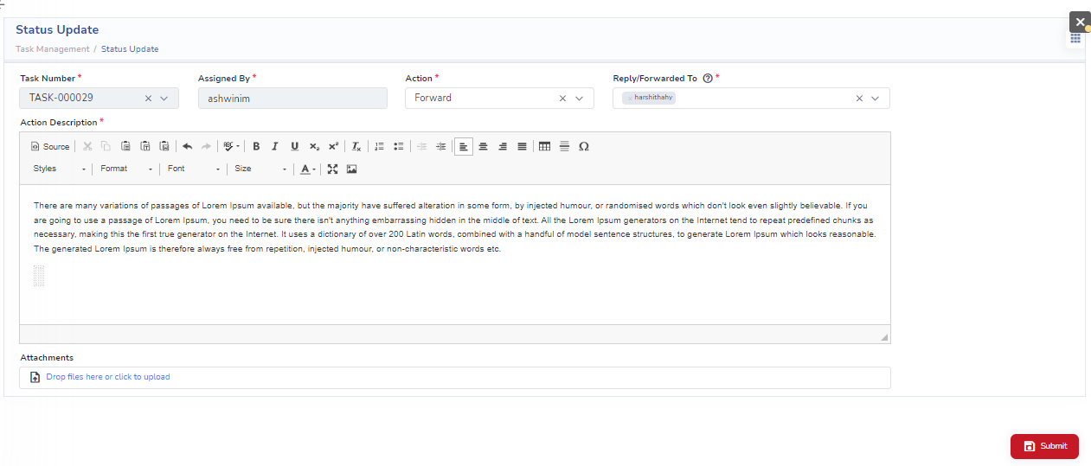

In Action field these are the functionality

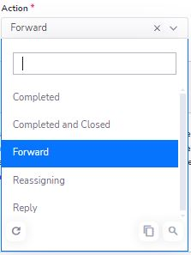

After this task will be assigned according to the requirement of that Task.After all the activities are done Task Initiator will close the Task by using Completed and Closed.

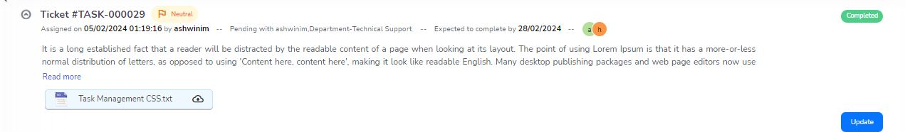

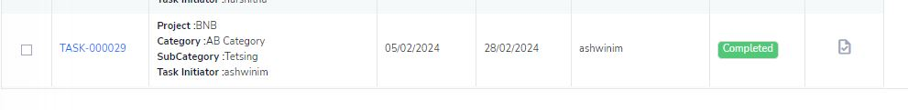

CONCLUSION:

Task management system incorporates components such as Project Master, Category Master, Subcategory Master, Task Form, and Status Update, provides a robust foundation for streamlined project organization and progress tracking. The Project Master serves as a central hub for overseeing projects, while the Category and Subcategory Masters enhance task organization. The Task Form provides a user-friendly interface for entering and updating task details, and the Status Update table captures a comprehensive log of actions and communication related to each task. Together, these components facilitate effective collaboration, efficient task management, and thorough documentation of project activities, contributing to improved productivity and project success.